
Business, Society and Technology
IFE, 3rd semester

LAB REPORT
MANUFACTURING
Lab no. 6
Title: Pneumatic drives and control

Date of lab: 22/01/2025
No. | SURNAME Name | Album No. | Lab group
1. | OGŁUSZKA Michał | 257104 | BST_en_1
2. | KOTOWICZ Stanisław | 257100 | BST_en_1
3. | GARA Maciej | 257093 | BST_en_1

Introduction
Our recent laboratory session on Pneumatic Drives and Control offered a deep dive into how we use compressed air to power the modern world. At its core, pneumatics is capturing energy in the form of pressurized air to perform mechanical tasks. It’s a fascinating field because, while it seems simple, it is the backbone of industrial automation. Pneumatics proves you can run an entire factory without a single electrical wire if you have a strong enough compressor. This independence makes it an incredibly adaptable technology to different grounds.

2. Technical Description
Pneumatic systems operate through a cyclical process of energy conversion. Atmospheric air is drawn into a compressor, pressurized, and stored in a tank. This stored energy is then regulated through control valves and distributed via a network of piping to actuators (cylinders or motors), where the fluid energy is converted back into mechanical motion.

2.1 Advantages and Disadvantages
The selection of pneumatics for industrial applications is generally based on a balance of environmental and safety factors against operational costs.
System Advantages:
- Resource Availability: Air is an easily available and cost-free medium.
- Environmental Safety: Compressed air is non-flammable and non-explosive, making it ideal for hazardous environments. Furthermore, the medium does not pose the risk of chemical contamination associated with hydraulic fluids.
- Operational Safety: Pneumatic systems are generally less dangerous than hydraulic systems. Leaks are easier to manage and do not present the same high-pressure injection hazards.
System Disadvantages:
- Capital Investment: The initial procurement and installation of compressors, dryers, and filtration units can be substantial.
- Maintenance Requirements: The presence of moisture and condensation within the lines can lead to component corrosion and operational failure if not properly managed through drying and lubrication.
- Energy Efficiency: Pneumatics are less efficient than mechanical or electrical drives due to energy lost to heat during the compression process and the potential air leakage.

3. Equipment

3.1 Compressor
The compressor is the heart of the system responsible for converting mechanical energy into pneumatic power.
- Positive-Displacement Types: These function by physically reducing the volume of a trapped air mass.
  - Piston (Reciprocating) Compressors: These operate via a linear drive where a piston moves within a cylinder to compress air. They are often multi-stage, cooling the air between compression cycles to increase efficiency. They are ideal for high-pressure requirements but produce a "pulsating" flow.

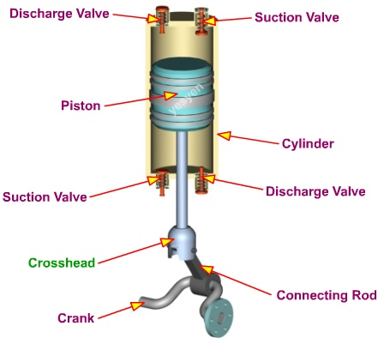
Fig.1 Piston (reciprocating) compressor

  - Rotary Screw Compressors: These use two meshing helical screws to trap and compress air continuously. They are the industrial standard for manufacturing due to their low noise levels and ability to provide a constant, pulse-free air supply for 24/7 operations.

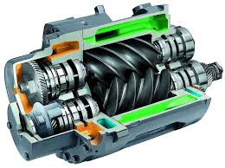
Fig.2 Rotary screw compressor

3.2 Storage and safety elements
Before air enters the distribution network, it must be stabilized and secured.
- Air Tank (Receiver): A large pressure vessel that stores compressed air. It serves two main purposes: compensating for pressure fluctuations during high demand and allowing moisture to precipitate (turn into liquid) so it can be drained.
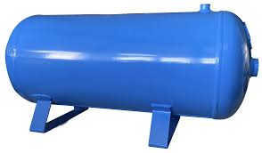
Fig. 3 Air tank
- Safety Valve: A critical mechanical fail-safe mounted on the tank. If the pressure exceeds a pre-set limit, the valve opens automatically to vent air into the atmosphere, preventing a catastrophic tank failure.
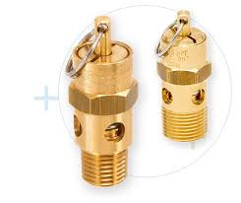
Fig. 4 Safety valve
- Non-Return Valve: This allows air to flow from the compressor to the tank but prevents it from flowing backward when the compressor stops, maintaining system pressure.
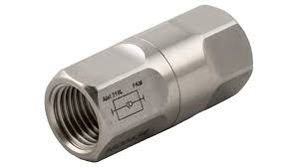
Fig. 5 Non-return valve
- Pressure relay: controls compressor operation by tank’s pressure control

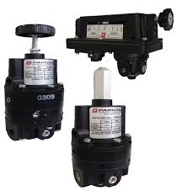
Fig. 6 Pressure relays

3.3 FRL Unit
Conditioning ensures the air is clean and stable before it reaches sensitive control valves. This is usually handled by a modular FRL unit (Filter, Regulator, Lubricator).
- Filters: Using centrifugal force, filters spin the air to throw water droplets and heavy particles against the bowl walls. A standard filter (5 μm) removes dust and scale, while a fine filter (0.3 μm) removes oil aerosols.

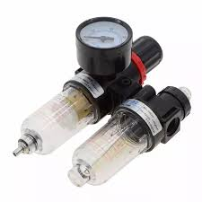
Fig. 7 Pneumatic Twin Air Filter
- Pressure Regulators: These use a spring-loaded diaphragm to reduce the variable "input" pressure from the main line to a constant, lower "working" pressure required by the tools.
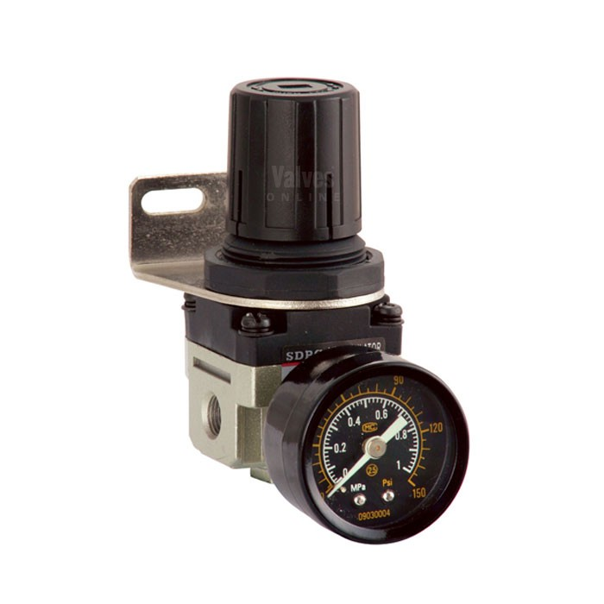
Fig. 8 Pneumatic Pressure Regulator
- Lubricators: These introduce a controlled "mist" of oil into the air stream. Using the vacuum created by air flow, they ensure that the internal seals of valves and cylinders stay lubricated to prevent friction-based wear.
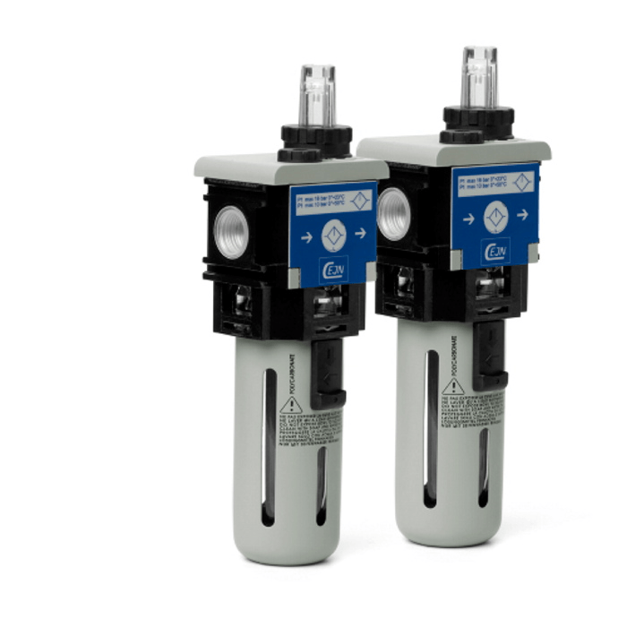
Fig. 9 Pneumatic Lubricator

3.4 Valves
Valves manage the logic of the system, including direction, pressure, and speed.
- Directional Control Valves (e.g., 3/2, 5/2): These dictate the path of the air. A 5/2 valve (5 ports, 2 positions) is typically used for double-acting cylinders; it switches the air supply between the "extend" and "retract" chambers.
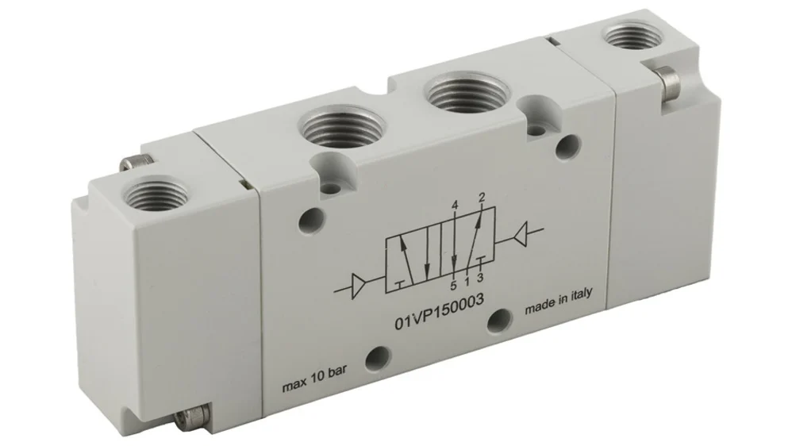
Fig. 10 Directional Control Valve 5/2

- Flow Control (Throttle) Valves: These regulate the volume of air passing through a line. They are used to control the velocity of an actuator. When combined with a check valve (non-return throttle), they allow the piston to move slowly in one direction while returning at full speed.
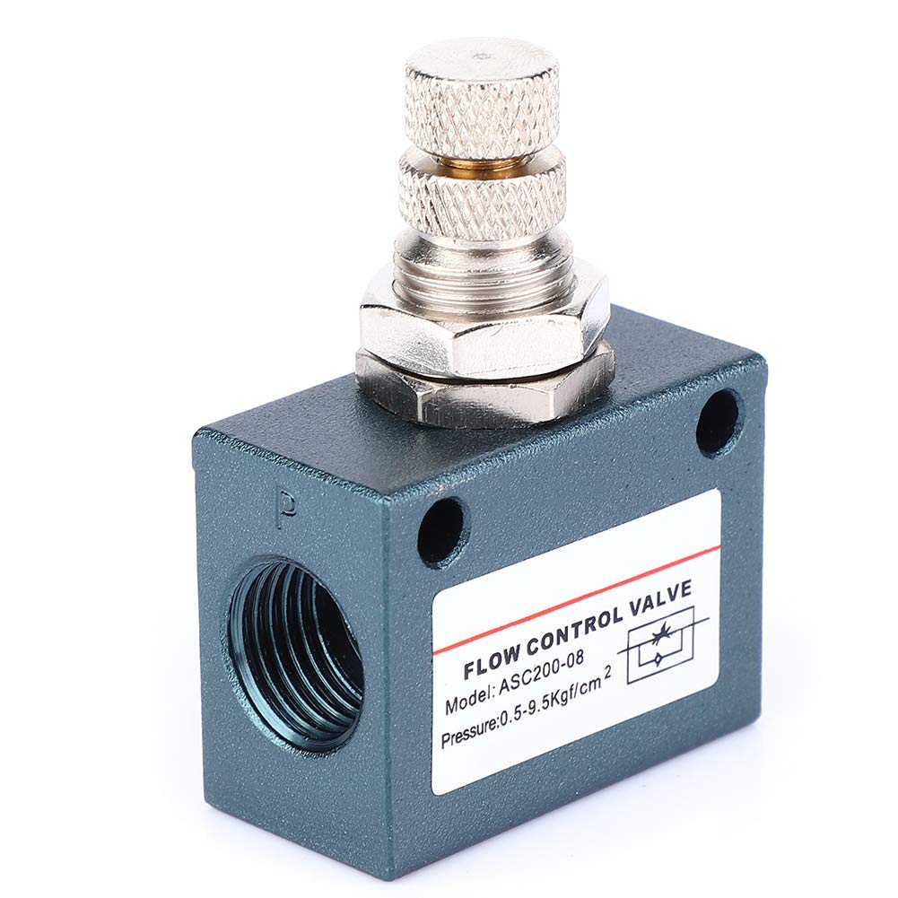
Fig. 11 Flow Control Valve

3.5 Actuators
Actuators convert the pneumatic potential energy back into physical work.
- Piston Rod Cylinders:
  - Single-Acting: Air moves the piston in one direction, and a built-in spring returns it.
  - Double-Acting: Air is supplied to both sides of the piston for controlled movement in both directions.

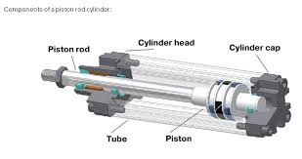
Fig. 12 Piston rod actuator single acting

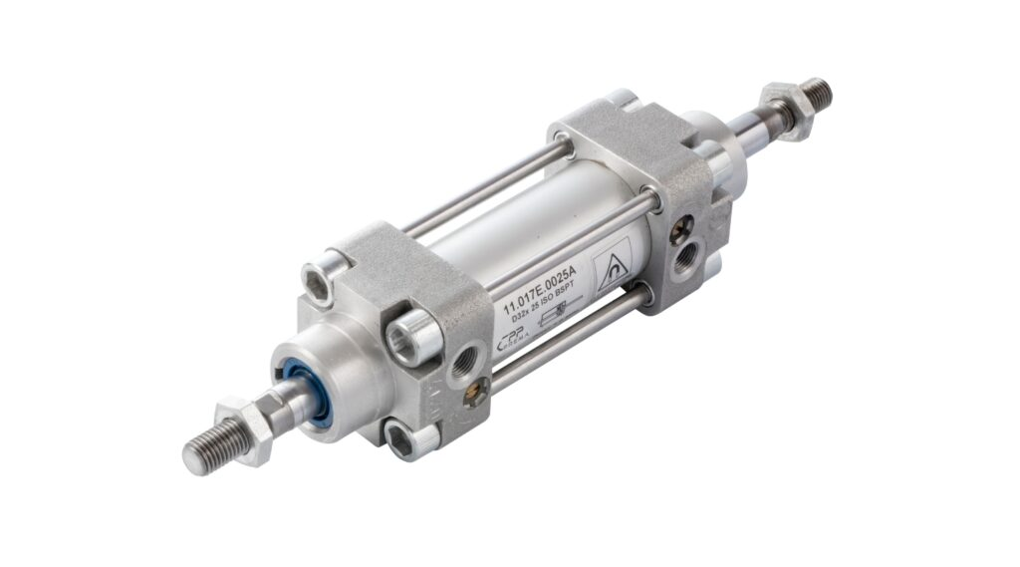
Fig. 13 Piston rod actuator double-acting
- Rodless Actuators: Instead of a rod, a carriage moves along the outside of the cylinder body via a mechanical or magnetic link. These are essential for long-stroke applications in tight spaces.

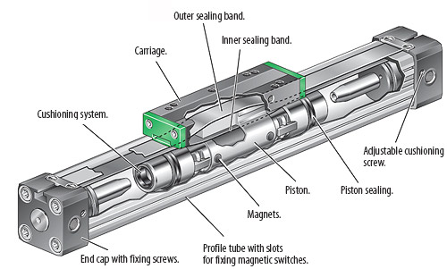
Fig. 14 Rodless pneumatic cylinder

- Rotary Actuators: These use a rack-and-pinion or vane system to turn linear air pressure into a twisting (rotary) motion, often used for robotic grippers or turning parts on a conveyor.
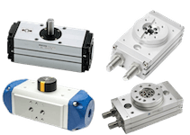
Fig. 15 Rotary Actuators

4. Throttle Check Valve

A throttle check valve (also called a flow control valve with bypass) is a combination of two valve functions in a single unit: an adjustable throttle valve and a check valve arranged in parallel.

How it works:
In one direction, air flows through the adjustable throttle (needle valve), which restricts the flow rate. By adjusting the throttle opening, the speed of the pneumatic actuator can be precisely controlled. In the opposite direction, the check valve opens and allows air to bypass the throttle completely, permitting free unrestricted flow. This design is commonly used to control cylinder speed: slow extension with throttled flow, and fast retraction with free return flow (or vice versa).
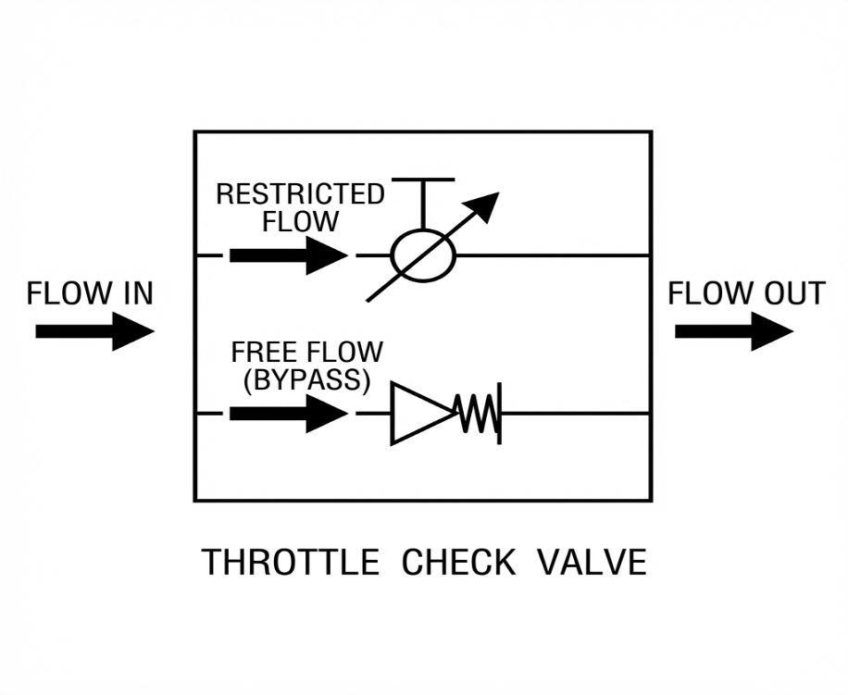
Fig. 16 Throttle Check Valve schematic

5. Pneumatic System Design

The following pneumatic circuit was designed and built during the laboratory session. The system consists of an air supply unit (FRL), a 5/2 directional control valve actuated by two 3/2 push-button valves, throttle check valves for speed control, and a double-acting cylinder as the actuator.
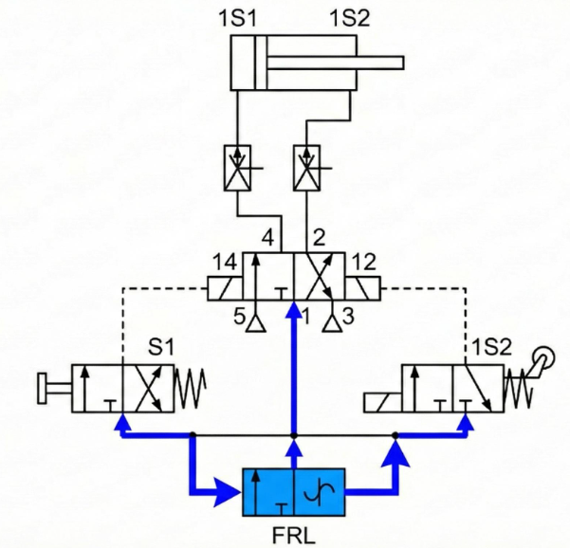
Fig. 17 Pneumatic system circuit diagram

6. Conclusions

This laboratory on pneumatic drives and control provided practical experience with industrial pneumatic systems and their components.

The main components of a pneumatic system were examined, including compressors, air treatment units (FRL), directional control valves, flow control valves, and actuators. Each component plays a specific role in converting compressed air energy into controlled mechanical motion.

The throttle check valve was identified as a key component for actuator speed control, allowing restricted flow in one direction while permitting free flow in the opposite direction.

The practical exercise of designing and building a pneumatic circuit reinforced the theoretical knowledge and demonstrated how individual components work together to create a functional automation system.

